Advanced Acting
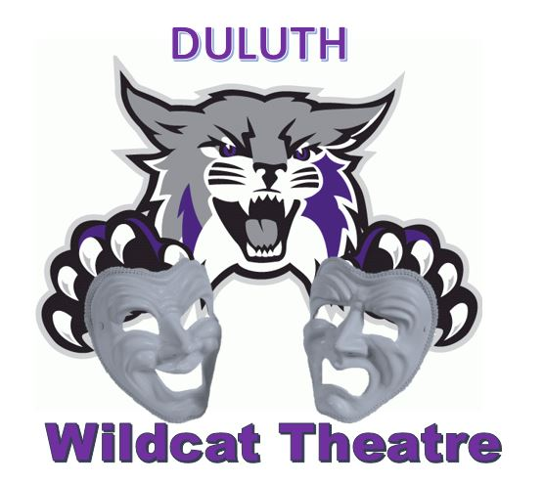
2018- 2019 Syllabus
Duluth High School

Instructor Contact Information
Brandy Carter
brandy_carter@gwinnett.k12.ga.us

Course Description
The goal of the course is to provide students the opportunity to explore a variety of acting methodologies. Students will be introduced to acting as a process. The course includes an introduction to a variety of contemporary acting techniques and methods from teachers including Konstantin Stanislavski, Uta Hagen, Viola Spolin, Kenneth Stilson, Kristin Linklater and others. If time permits (and there’s student interest) we may also explore some period acting (Shakespearean, Greek). Emphasis will be placed on acting exercises, physical and vocal awareness and practical (honest and committed) application of techniques and theories. Classes include exercises in movement, improvisation, character development, vocal expression, articulation and projection, relaxation exercises, concentration, sensory awareness, emotional recall, working in the moment, given circumstances, and text analysis. This work develops skills in creativity, critical thinking, collaboration, communication, perseverance and leadership. Classes will also include performances and responding to your own and others’ class work and performances in journal writings and discussion.

Required Materials – Please have by Friday August 10, 2018
- Acting Journal – Periodically journal entries will be done in class. You will need a spiral notebook or composition book to complete these.
- Pen or pencil
- A pocket folder for class handouts and written work
- Comfortable clothing which allows you to move freely

Assignments and Expectations
1. Attendance and Participation This is a hands-on class and you are responsible for attendance and participation. Your full participation is essential for your development as an actor and is essential for the success of the class as a whole. Tardies, coming late to class or leaving early, will impact your daily grade as that will effect your ability to participate fully. If you’re absent please see me the next class when you return for a make-up assignment or to go over what was missed.

2. Drinks, foods and other distractions You are welcome to have bottled water in class. Other food and drink should not be consumed during class. Cell phones must be turned off and left in a backpack, bag or jacket pocket. You may not carry a cell phone in class. Again, this is a hands-on class that requires focus and engagement. If a break is given you may use cell phone during break.

3. Dress Students should dress in comfortable clothing that allows for unrestricted movement. You will be sitting on the floor, stretching, running, moving – please wear clothing that allows you to do this. Shoes need to be sneakers, ballet, character or jazz shoes, or bare feet – no boots, heels or thick-soled (platform-type) shoes. You may choose to bring suitable clothing and change for class. Changing for class must occur before the start of class. You must be ready to warm-up or participate in class in other ways by the class bell.

4. In-class acting exercises – Daily class work consists of acting exercises including: actor’s warm-ups and relaxation techniques, development of senses, awareness and development of focus, and basic acting skills through participation in a wide variety of drama games, improvisational activities, pantomime/movement exercises and vocal exercises.

5. Acting Journals Each student will keep an Acting Journal. They will reflect your development as an actor and your growing understanding of process. These should be thoughtful entries that reflect on class work, your understanding, your questions and your reflections. These will usually be assigned on Fridays in order to reflect on the work of the week. Class time will be given to complete your entries. If the class time is insufficient you will need to finish these as homework. Journal entries will include the following:
- Class notes and descriptions of class work
- Reflective and or creative responses/comments to classroom work, acting skill development
- Comments on performances both in and outside of class
- Character and life observations relevant to class work and assignments
- Character analysis that is relevant to class work and assignments
- Other responses/reflections as assigned
The Acting Journal is your documentation of this class and the process you are developing. I’ll comment on these regularly. I’m interested in the way you thoughtfully exercise your creativity and imagination with regards to developing acting techniques. Being absent from class doesn’t excuse you from journal entries. See the teacher the next class when you return to get a make-up Journal Entry assignment. Occasionally I’ll share a journal entry in class when appropriate.

6. In-Class Practical Exercises/Performances This is a hands-on class and you’ll be performing regularly, sometimes alone and sometimes working with a partner. The majority of class assignments and exercises will involve partner, small or whole group work. You’ll have class time to rehearse, but there may also be a need to rehearse alone or with a partner outside of class or memorize lines for homework. It is important that you honor rehearsal/performance dates/times. Do not let you acting partner down! Please note that in-class performance dates include watching your classmates work and may be two days of class time. In addition to daily exercises in-class performance assignments include:
- Character Improv Acting Scene
- Monologues
- Open Scenes
- Public (Play/Musical) Performance
- Final Scenes – this is your final exam. It will be a 5 – 10 minute scene from a contemporary published play with age appropriate characters.
**NOTE** Similar performance assignments may be substituted based on student progress and interest.

7. Written Work All written work with the exception of the Written Observation Exercise must printed legibly or word-processed. Please no less than 11 pt. Length will vary based on your ability to address the assignment completely and concisely.
- Written Observation – required preparation for the Character Improv Acting Scene and includes notes on the initial observations of 3 individuals, analysis and synthesis paragraph, description of character, and an outline of the improvised scene (character relationship, setting, action, plotline/aka who, what, where and what your character wants “is fighting for” in the scene). In Journal, but graded separately.
- Monologue Character analysis. In Journal, but graded separately.
- Beat Analysis/Questions for final scene. In Journal, but graded separately.

8. In-Class discussions – Discussions will be a regular part of class and will include discussions of performances both in and out of class, class work and exercises and readings. Students are required to attend at least one DHS Wildcat Theatre production (in which they are not involved) each semester. Students must attend all DHS productions in order to vote in the end of year awards.
Theatre students receive a discount ($3 donation) for all shows in which they are not involved.

Grading
Students will be graded on a combination of performance assignments, practical exercises, written assignments and improvement. Please remember that full participation is part of your grade. If you have a question about your grade at any time during the semester please contact me. Percentages may change:
- Daily Work- 35% Includes student incorporating on-going feedback/formative assessment, development and progress of acting skills
- Journals- 10%
- Written Work - 10%
- Performances- 45%
A word on grading – progress/improvement is a part of your grade both on your performances and in your daily work. While daily work is worth 35% please keep in mind that daily work feeds your performance work and also your progress/improvement in the class. This is considered for each individual. Students will be involved with responding to their own and other’s work as well as the teacher’s feedback on work. Being absent doesn’t excuse you from any assignments. Speak to Ms. Carter before or after class on the day you return to create a plan to finish missed work.

Please return this page to Mrs. Carter by Friday August 10, 2018.

_________________________________________________________________________________________________________________

I have read and understand the Class Syllabus and have shared this information with my parent/guardian.

Student Signature: _______________________________________________________________________

Parent Signature: _________________________________________________________________________

Student Name (print): ____________________________________________________________________

Student Contact Info Phone/email: __________________________________________________________________________

Parent Contact Info Phone/email: ___________________________________________________________________________

