Syllabus- Technical Theatre
Course Syllabus
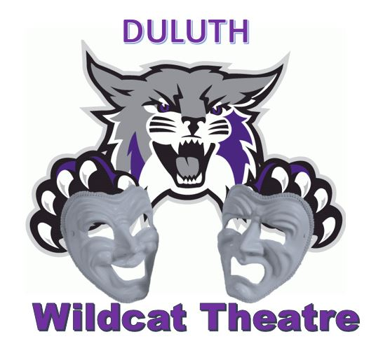
Duluth High School
2018- 2019
"Measure twice, cut once."
COURSE REQUIREMENTS

Course Objective:
Technical Theatre at Duluth High School is an opportunity for students to explore themselves in art and art in themselves. The course focuses on stage craft techniques that are the foundation for technical theatre. The technicians will learn to interpret and execute a theatrical designer's plans, much like a beginning actor learns how to interpret and execute a playwright's script. Through projects and work on Mainstage productions, students gain the confidence and technique needed to become a skilled technician.

Technical Theater requires commitment to certain performance dates for school productions as well as participating in a MINIMUM of 20 hours of after school work in the scene shop.
COURSE CONTENT:
1. Introduction to the stage & Stage Safety: Stage types, Areas of the stage, Curtains and Rigging Introduction.
2. Make-up: Make up supplies and application techniques, special effects make up.
3. Jobs in the Theatre: The many people it takes to produce a show and the jobs that they do.
4. Scenic Construction: Physical construction of scenery, painting and texturing
techniques, evaluating scene designs, building.
5. Costume Design: Designing and selecting costumes for production. Researching costume periods and styles.
6. Scene Design Basics: Types of design media, genres of design, analysis of the script. Drafting, creating scene designs for specific scripts, justifying and explaining design choices, presenting designs.
7. Lighting: History of stage lighting, lighting safety and types of fixtures Electronic control of stage lighting, Intelligent Lighting Controls, designing for the stage using color, intensity and line.
8. Properties: Construction of Props, Props management, creation of three dimensional props
9. Sound: Sound system basics. Sound boards, microphones, and speakers. Setting up and running sound systems, using wireless lavalier microphones, using portable sound systems, describing how audience perception is considered in sound design.
COURSE EVALUATION:
Projects: Each project will be graded with a rubric that breaks down its components.
Missing Assignments: Missing assignments can be made up at the instructor’s discretion.
If an assignment is missed it will be marked with an N/A in the grade book which results in zero points until the assignment is made up. Points will be deducted for late work; 5 points will be deducted for each day late until the assignment is turned or the grade reaches 0. Grades will be posted in a timely fashion. Please allow at least one week after the due date for major assignments to be posted.
Academic Dishonesty:
Students are expected to complete all tests and assignments honestly and will not collaborate in dishonest actions. Students will not give or accept answers or assignments unless directed to by the teacher. Students caught cheating or plagiarizing will be subject to discipline as stated in the Student Handbook.
Attendance: You MUST be in class on time. PERIOD. There are many in-class graded assignments – if you aren’t here – you will not be able to complete them. If you are unexcused that day – you will lose those points.
Participation: Because the majority of work for this course will be completed in class, students will be expected to always put forth their best effort during class time.
Performance Attendance: Students are expected to work 1 Duluth production each semester.

SUPPLIES:
- PENCILS
- PAINT BRUSHES- Each student is asked to provide a 3” paint brush, a 2” paint brush, and a 1” paint brush and write their name (in Sharpie) on their brushes. If the student does not properly wash out their brushes, and the brushes become unusable, the student will need to provide additional brushes.
- WORK CLOTHES: When we are working on sets you must be dressed appropriately. Keep something at school that you can build or paint in. NO OPEN TOED SHOES!!!! Keep long hair pulled back. I will not listen to you whine that you got primer on your clothes or jewelry or that you got sawdust on your best sweater. If I do not think you are dressed to work, I won't let you and that means no daily points for that day. EXPECT TO GET MESSY EVERYDAY.
Classroom Rules and Expectations:
1. Tardies – you are tardy if you enter the room any time after the bell rings
2. Have your supplies ready at the beginning of class.
3. Horseplay of any kind can result in immediate referrals.
4. You may bring water to class, no other food or drink.
5. Be sure your paint clothes are always available for class.
6. During construction and production of shows ALL SAFETY procedures MUST BE STRICTLY FOLLOWED!
*REMEMBER: Quick and convenient solutions are usually NOT the safest solutions.
* walk in the shop
* use tools safely
* listen and follow instructions
* do not distract others
* clean up when work is finished
* share tools with others
* wear safety glasses while operating power tools at all times.
7. AS YOU WILL BE WORKING ON EVERY SHOW IN SOME CAPACITY, YOU WILL NOT BE REQUIRED TO PAY THE THEATRE PARTICIPATION FEE!
8. DO NOT leave the work area FOR ANY REASON without permission.

Grading

Students will be graded on a combination of performance assignments, practical exercises, written assignments and improvement. Please remember that full participation is part of your grade. If you have a question about your grade at any time during the semester please contact me. Percentages may change:
- Daily Work- 35% Includes student incorporating on-going feedback/formative assessment, development and progress of technical skills
- Journals- 10%
- Written Work - 10%
- Performances- 45%

A word on grading – progress/improvement is a part of your grade both on your performances and in your daily work. While daily work is worth 35% please keep in mind that daily work feeds your performance work and also your progress/improvement in the class. This is considered for each individual. Students will be involved with responding to their own and other’s work as well as the teacher’s feedback on work. Being absent doesn’t excuse you from any assignments. Speak to Ms. Carter before or after class on the day you return to create a plan to finish missed work.

Grade % Equivalent Description

A – 100 – 90, Excels in class
B – 89 – 80, Above average
C – 79 – 70, Average
D – 69 – 60, Below average
F – 59 – 0, Failing

Please return this page to Mrs. Carter by Friday August 10, 2018.

_________________________________________________________________________________
I have read and understand the Technical Theatre Class Syllabus and have shared this information with my parent/guardian.

Student Signature: _______________________________________________________________________

Parent Signature: _________________________________________________________________________

Student Name (print): ____________________________________________________________________

Student Contact Info Phone/email: __________________________________________________________________________

Parent Contact Info Phone/email: ___________________________________________________________________________

